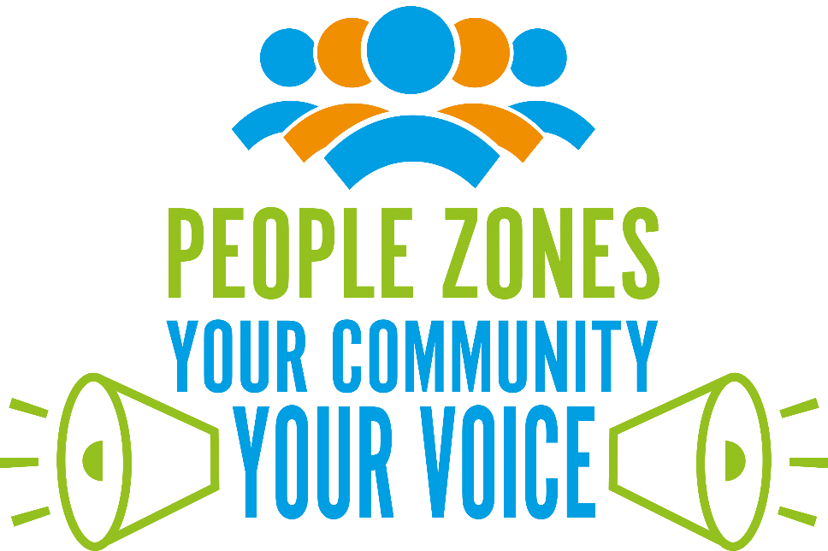

NEW PARKS PEOPLE ZONE

GRANTS APPLICATION FORM

|  |
| --- |
| People Zones are locations with a boundary attached that has been identified through crime and public health data.  People Zones follow an Asset Based Community Development approach which focuses on highlighting what assets are in the area and how we can help communities to build upon and enhance them.  The hope is to empower residents and workers to work collaboratively to become a stronger, safer and self-sustaining community.  To apply for People Zone funding, you must be living, working or providing a service within a People Zone, and your project must meet on or more of the themes identified with the research report (a link can be found on page three).  For more information please visit: [**https://www.peoplezones.co.uk**](https://www.peoplezones.co.uk) |



|  |
| --- |
| When you have completed this form please submit it with your Eligibility Statement and relevant documentation to: [**people.zones@leics.police.uk**](mailto:people.zones@leics.police.uk)**.**  **Please ensure you have adhered to the word limits for each question. Anything written beyond these limits will be disregarded and not taken into consideration.** |

|  |  |
| --- | --- |
| **CONTACT DETAILS** | |
| **Organisation Name:** |  |
| **Project Name:** |  |
| **Contact Name:** |  |
| **Email:** |  |
| **Phone Number:** |  |
| **Social Media Accounts and webpage:** |  |
| **Amount of funding applied for one year:** |  |
| **Delivery location and geographic reach of service:** |  |
| **What will the funding be used for:**  (please check one of the boxes and explain your reasoning below) | 1. For a new initiative |
| 1. To expand existing services |
| 1. Replacement funding |
|  | |
| **Data Protection 2018** | Should you be successful, do you consent to the People Zone team to hold your contact information for three financial years from the point of the award of the funding? |
| Yes:  No: |
| **How did you hear about this funding?** |  |

|  |
| --- |
| A professionally conducted community consultation was recently undertaken by an external provider called Mapping for Change. Data was collected from semi-structured interviews, informal conversations, online and paper surveys, workshops and focus groups.  The views and opinions of residents and workers across the community have been collated into a research report, which can be found on the New Parks People Zone page of the website: [**https://www.peoplezones.co.uk/new-parks**](https://www.peoplezones.co.uk/new-parks).  The results from the report highlighted the following key themes the community felt needed to be addressed:   * **Crime and Anti-Social Behaviour** – Perceived to be a large issue in the area and major concern for residents, particularly including knife crime and nuisance caused by motorbikes and scooters in inappropriate areas and at late hours. * **Community Safety** – Regarding feelings of unsafety whilst outside in the late evening, whether in groups and particularly when alone. * **Substance Use** – Perceived to be a considerable issue across the community, involving a wide range of age groups, regarding substances and alcohol. * **Health and Wellbeing** – Poor mental health is a widespread issue across the community with perceived poor access to support services and urgent care. * **Pride of Place** – Encourage enhanced pride in the community through tackling issues including littering and fly tipping.   These themes will be a point of focus for the People Zone project going forward, in order to support the New Parks community in their journey to becoming stronger, safer, more cohesive and self-sustainable.  Please align your application to one or more of the above identified themes in order to be eligible for People Zone project grant funding |

|  |
| --- |
| **PROJECT DETAILS** |

|  |
| --- |
| 1. **Which theme(s) does your project cover?**   Please clearly list any themes that your project will address and provide a brief explanation as to how your project will meet said theme(s).  **Word limit 400 words max (Medium)** |
|  |

|  |
| --- |
| 1. **What problem or need will your project address?**   Please describe the need or problem. Your response should:   * 1. Clearly define the problem or need and relate it to an element of the research report. Demonstrate how the project will meet the theme(s) highlighted in the research report.   2. Identify the local demographic of people whom this problem affects/who have this need. Please provide evidence to demonstrate this need. This can be quantitative (figures and data) or qualitative (a narrative based on community engagement and consultation.   **Word limit 500 words max (High)** |
|  |

|  |
| --- |
| 1. **What will your project do?**   Please provide a project plan that includes mobilisation, key milestones, named persons of responsibility, delivery locations and key activities. Your plan should clearly set out:   * 1. What will be delivered/provided and how frequently.   2. Who will deliver/provide it.   3. What resources are required to deliver the project.   4. When the key activities will take place (including days of the week and timings).   **Word limit 500 words max (High)** |
|  |

|  |
| --- |
| 1. **How will you demonstrate that your project has been successful?**   Please describe the impact your project will have. Your response should clearly set out:   * 1. Who you expect to impact with your project.   2. What the impact of the project will be.   3. How you will measure this impact.   **Word limit 400 words max (Medium)** |
|  |

|  |
| --- |
| 1. **What relevant experience do you have that will be beneficial for this project?**   Please describe your skill set or experience in delivering similar projects which will enable you to deliver this project successfully. Your response should set out:   * 1. Any previous experience in delivering a project or initiative. Include details of when this took place, any relevant stakeholders, and the target audience. Please demonstrate the success of this project or initiative, including evidence and detail how this was measured.   OR  The relevant skill set and personal experience within your organisation which would enable you to deliver this project. Please detail how these skills will enable you to do so.  **Word limit 400 words max (High)** |
|  |

|  |
| --- |
| 1. **Please provide a breakdown of the costs of your project.**   Please show how the funding will be used using **TABLE A**. This should reflect all aspects of the project that are dependent on People Zone funding.  Your response should also demonstrate value for money.  If your project is being co-funded, i.e., with another party then please provide these costs in **TABLE B**. Only leave blank if not applicable.  **(High)** |

**TABLE A**

The costs below are provided as a guide. Please populate as relevant and add additional costs as required. If you plan to purchase equipment or resources with this funding, please submit any quotations along with this application.

|  |  |  |
| --- | --- | --- |
| **WHAT?** | **BREAKDOWN** | **COST?** |
| Equipment |  |  |
| Resources |  |  |
| Installation |  |  |
| Training |  |  |
| Marketing |  |  |
| Venue |  |  |
|  |  |  |
|  |  |  |
|  |  |  |
|  |  |  |
| **GRAND TOTAL** | | **£** |

What would be the impact should you not be awarded this funding?

|  |
| --- |
|  |

**TABLE B**

Please provide a breakdown below of all aspects of the project that are reliant on additional funding being acquired (not from People Zones).

|  |  |  |
| --- | --- | --- |
| **WHAT?** | **BREAKDOWN** | **COST?** |
|  |  |  |
|  |  |  |
|  |  |  |
|  |  |  |
|  |  |  |
|  |  |  |
|  |  |  |
|  |  |  |
|  |  |  |
|  |  |  |
| **GRAND TOTAL** | | **£** |

What would be the impact should you not be awarded this funding?

|  |
| --- |
|  |