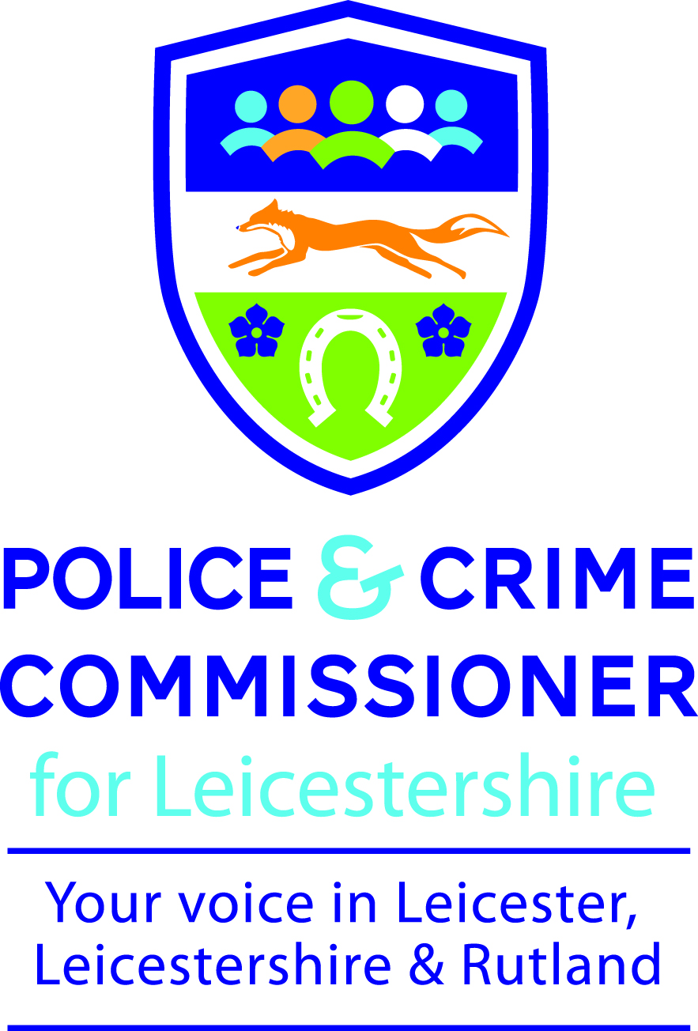

Meeting: ETHICS, INTEGRITY AND COMPLAINTS COMMITTEE

Time/Date: FRIDAY 4 DECEMBER 2015 – 2.00 P.M.

Location: MAIN CONFERENCE ROOM,
POLICE HEADQUARTERS, ENDERBY

Officer to contact: ANGELA PERRY,
HEAD OF GOVERNANCE AND ASSURANCE

AGENDA

Item |  |  | Report of | Paper  Marked
1. | Apologies
2. | Urgent Business
3. | Declarations of Interest in Items on the Agenda
4. | Minutes of meeting held on 25 September, 2015
5. | Training Plan for Members |  | Police and Crime Commissioner | A  TO FOLLOW
6. | Complaints and Misconduct |  | Chief Constable | B
7. | Facial Recognition |  | Chief Constable | C
8. | The Code of Ethics |  | Chief Constable | Verbal
9. | Ethics Issues |  | Chief Constable | D
Members |  | Officers Attending
Dr Stephen Cammiss  Ms Lois Dugmore  Dr Mark Peel  Ms Lynne Richards  Prof. Cillian Ryan |  | Mr P Stock, Chief Executive, OPCC  Mrs A Perry, Head of Governance and Assurance, OPCC  Mr R Bannister (Deputy Chief Constable)  Mr M Tapp, Strategic Head Of Communications and Public Engagement  Mr M Ball, Superintendent, Head of Professional Standards

