POLICE AND CRIME COMMISSIONER FOR LEICESTERSHIRE
PAPER MARKED
E

JOINT AUDIT, RISK AND

ASSURANCE PANEL

Report of | CHIEF CONSTABLE
Subject | Internal structures and procedures in place as counter-fraud and anti-corruption measures
Date | TUESDAY 5TH JULY 2016 – 1.00 P.M.
Author : | PAUL DAWKINS - ACO FINANCE & RESOURCES

Purpose of Report

- This report provides the Panel with updated details of the robust processes and procedures Leicestershire Police currently has in place to identify and mitigate the likelihood of fraud. These complement and support the national measures that exist for scrutiny of the public sector and managing integrity across Police Forces in England & Wales.

Recommendation

- The Panel is recommended to note the content of the report.

National Standards

College of Policing – Code of Ethics
- The Code of Ethics 2014 has been produced by the College of Policing in its role as the professional body for policing. It sets and defines the exemplary standards of behaviour for everyone who works in policing. As a code of practice, the legal status of the Code of Ethics applies to the Police Forces in England & Wales under section 39A of the Police Act 1996 as amended be S. 124 of the Anti-Social Behaviour, Crime and Policing Act 2014.

- The Code of Ethics is about self-awareness, ensuring that everyone in policing feels able to always do the right thing and is confident to challenge colleagues irrespective of their rank, role or position.

- The Code’s Standards of Professional Behaviour: Section 1 – Honesty & Integrity
“I will be honest and act with integrity at all times, and will not compromise or abuse my position.”

- The expectation is that police employees will act with honesty & integrity at all times – examples of meeting this standard include:
- Ensuring decisions are not influenced by improper considerations of personal gain;
- Neither soliciting nor accepting the offer of any gift, gratuity or hospitality that could compromise impartiality.

- The Code of Ethics has been embraced by Leicestershire Police with its values being mainstreamed throughout the Force. An awareness campaign was run by the Corporate Communications Department when the Code was launched. There are hyperlinks to the College of Policing website and full Code and the Summary on the PSD internal website and HR Document Library. HMIC’s 2015 Legitimacy inspection noted: -

The force had a well established set of values that promote ethical behaviour that had been championed by the chief officer team. The approach the force was taking to the Code of Ethics was positive, and there was appropriate information available to the workforce.

National Fraud Initiative
- Since 1996 the Audit Commission has run the National Fraud Initiative (NFI), an exercise that matches electronic data within and between public and private sector bodies to prevent and detect fraud. This includes police Forces and OPCCs, local Probation Trusts and Community Rehabilitation Companies, fire and rescue authorities as well as local councils and a number of private sector bodies.

- NFI data matching plays an important role in protecting the public purse against fraud. For nearly two decades, the Commission has run the NFI exercise every two years to help detect and prevent fraud.

- The NFI brings together a wide range of organisations to tackle fraud. Fraud can happen anywhere and fraudsters often target different organisations at the same time, using the same fraudulent details or identities. The NFI can help tackle this by comparing information held by organisations to identify potential fraud and overpayment.

- A match does not automatically mean fraud. Often, there may be an explanation for a data match that prompts bodies to update their records and to improve their systems. The Police and Crime Commissioner and Chief Constable of Leicestershire are required by law to provide payroll, pensions and suppliers’ data.

- The main categories of fraud identified by the NFI in England relate to pensions, council tax single person discounts and housing benefit. Although, during the time the Force has been participating in the NFI, no frauds have been identified against the Force. There has however been one instance where a police officer was fraudulently claiming housing benefit. This led to prosecution at Court and a custodial sentence.

- Data matching showing little or no fraud and error can provide bodies with assurances about the effectiveness of their control arrangements. It also strengthens the evidence for the body’s annual governance statement.

- The use of data for NFI purposes continues to be controlled to ensure compliance with data protection and human rights legislation.

- The most recent 2014/15 NFI data-matching results for Leicestershire Police are shown in the table below:

NFI 2014/2015
 | Summary - Recommended Matches
 | Report Category | Total Recommended Matches | Number of Reports Reviewed | Results
 | Payroll | 14 | 62 | No issues - Closed
 | Creditors | 96 | 96 | No issues - Closed
 | Totals | 110 | 158
Local Strategies, Policies and Procedures to Promote and Enforce National Standards

Policies & Procedures
- A number of policies and procedures are in place which relate to managing integrity of Police officers and staff in Leicestershire to which all individuals are required to adhere. These include:

- Police Staff Standards of Professional Behaviour
- Police Officer Standards of Professional Behaviour
- Anti-Corruption Policy supported by the following procedures:
    - Substance Misuse
    - Confidential Reporting
    - Business Interests
    - Debt Management
    - Gifts, Gratuities & Hospitality
    - Notifiable Associations
    - Misconduct Outcomes Publications
    - Protective Monitoring of Leicestershire Police Systems (not yet completed)
    - Internet Access & Social Networking Procedure
      - Vetting Policy and Guidance

- The policies and procedures are linked via the Integrity Model and disseminated through publication in the Documents Library on the Intranet and the PSD Website.
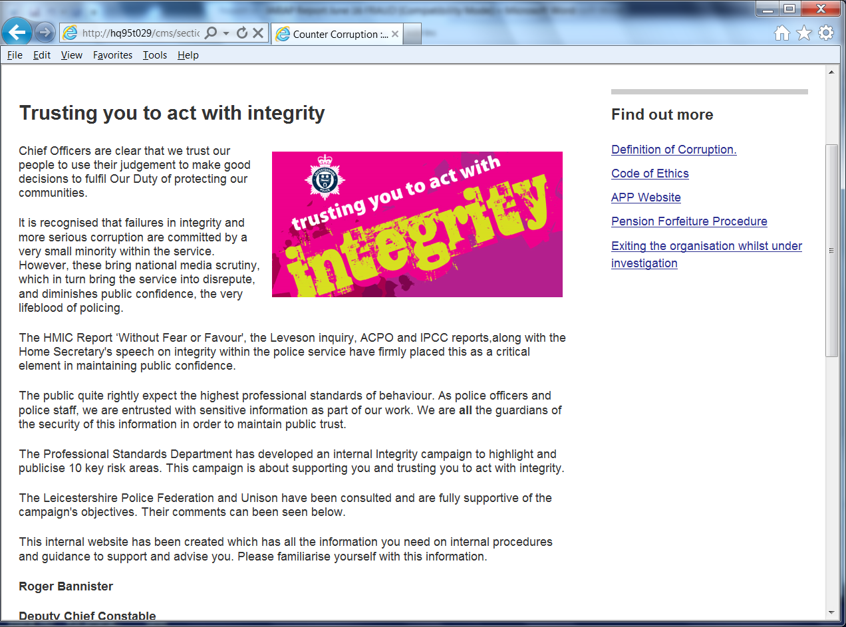
- The Force’s Integrity Development Plan, developed by the Professional Standards Department.

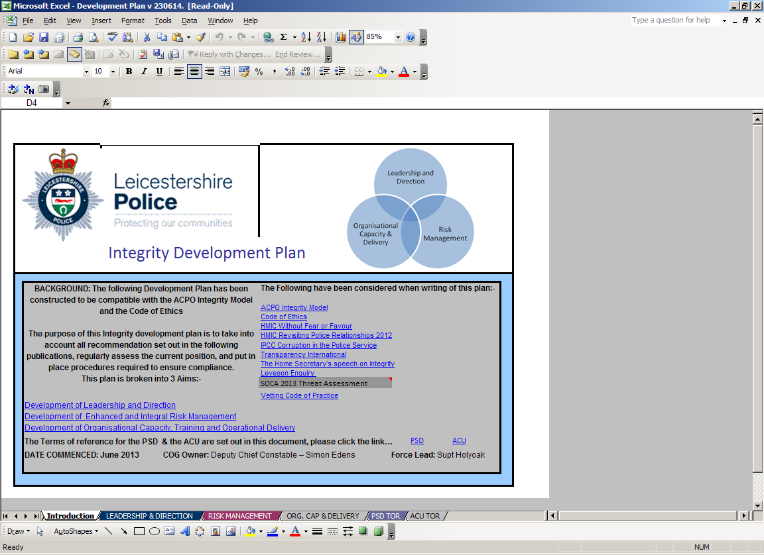

- Training is available through an Anti-Corruption package on the Managed Learning Environment.

- Supporting the Anti-Corruption Policy and the process of Confidential Reporting is the “Bad Apple” initiative, allowing concerns to be reported anonymously using e-mail, managed by the Anti-Corruption Unit in the Professional Standards Department.

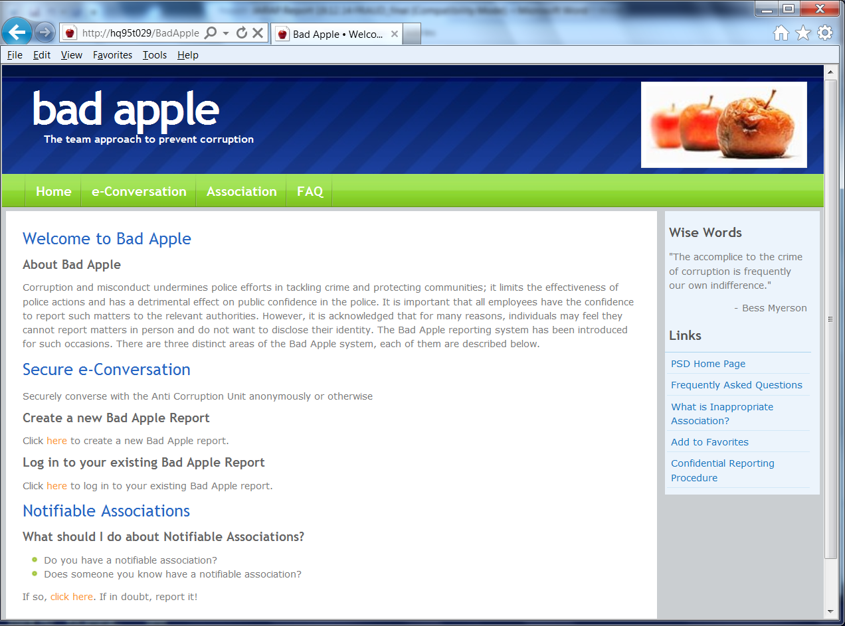
Procurement standards
- The Procurement Policy effective from January 2013 is accessible through the internal Procurement & Support Services website. In relation to managing fraud, it covers: -

- Confidentiality and Disclosure of Interest;
- Use of Contractors Services, Gifts and Hospitality;
- Corporate Supply Arrangements;
- Tendering Procedures for the Supply of Goods and Services; and
- Auditing.

- Credit card quarterly reporting is closely monitored by PSD to ensure that corporate credit cards are not being used to short circuit the correct Procurement processes and that the Force is not incurring costs are higher than they would be through normal audited processes. This is more of a responsibility to the taxpayer than an integrity issue, but the two are linked. In almost every case checked the spending is legitimate.

Internal and external audits

- Internal financial audits which would highlight any potentially fraudulent activity are conducted by Mazars LLP throughout the year on a cyclical basis, looking at different thematic strands.

- External audits which scrutinise the Force’s accounting procedures and which would identify and mitigate the likelihood of fraud are conducted by the accountants Ernst & Young annually, with preliminary, interim and final reports being submitted.

Her Majesty’s Inspectorate of Constabulary (HMIC) Inspections
- During w/c 09/05/2016 HMIC undertook this year’s PEEL inspection. PEEL is the programme in which HMIC draws together evidence from its annual all-force inspections. The evidence is used to assess the effectiveness, efficiency and legitimacy of the police. HMIC has introduced these assessments so that the public will be able to judge the performance of their Force and policing as a whole. The effectiveness of a force is assessed in relation to how it carries out its responsibilities including cutting crime, protecting the vulnerable, tackling anti-social behaviour, and dealing with emergencies and other calls for service. Its efficiency is assessed in relation to how it provides value for money. Its legitimacy is assessed in relation to whether the force operates fairly, ethically and within the law.

- Leicestershire Police was rated GOOD for efficiency, i.e. that is how well the Force delivers value for money, being well prepared to face its future financial challenges and having balanced the budget, with a good track record of achieving savings.

How well does the force monitor and understand outputs, outcomes and costs?
We found that the force has effective ways of monitoring its performance. The performance delivery group which is chaired monthly by the deputy chief constable has access to a range of data and information on which it can base its understanding of outputs, such as the costs of investigations.

The force currently understands its costs based on different functions, using the existing departmental budgets. It is planning during this financial year to understand better the cost of providing services through an outcome-based budgeting (OBB) exercise, which will start with the professional standards department. This approach will enables the force to understand the cost of providing services which in turn will allow it to compare the costs of services in other areas of the force.

How well does the force control expenditure?
Both HMIC and the force’s external auditors have previously credited the force with having strong financial management and controls in place. This continues to be the case and appropriate governance arrangements are also in place for the force’s change and savings plans.

- 2015 was the first year to provide a graded judgement from HMIC on legitimacy, i.e. whether the Force acts with integrity and provides a service the public expects.

- Leicestershire Police was graded GOOD overall for legitimacy. However, the inspection focused specifically on areas other than fiscal probity and financial fraud, such as ethical treatment around BME, best use of stop and search and best use of taser.

Update on Assurance in Relation to Seized and Found Property and the 2015-16 Property Review

- Op Ultima and Op Untimely refer. A series of internal audits and related staffing issues have highlighted that our organisational provision and processes relating to Property (Found and Other than Found / POTF) are in need of comprehensive review.

- In April 2015 a substantial amount of cash and jewellery was discovered to be missing from a safe stored at Tigers Place. A criminal investigation was launched and an audit of all safes held by Leicester Police was conducted. This was managed under the banner of Operation Ultima. The perpetrator was brought to justice and is currently detained at Her Majesty’s pleasure.

- As a result of the review, the property procedures and policy were reviewed and updated. A Force Safes Procedure has also been introduced. New guidelines in relation to the recovery, storage and disposal of cash have also been published.

- Between 14th and 16th March 2016, the Force was the subject of an internal audit by Mazars. Their remit was to audit the processes around the storage and movement of property held within safes.

- A full report into the current situation regarding Seized & Found Property and the new Safes Procedure form Agenda Item 15 to be presented to the JARAP meeting 5th July 2016.

Paul Dawkins
ACO Finance & Resources

Implications

Financial : | See report
Legal : | See report
Equality Impact Assessment : | N/A
Risks and Impact : | See report
Link to Police and Crime Plan : | Policing Protocol

Background Papers

N/A

Person to Contact

Paul Dawkins - ACO Finance & Resources – (0116) 248 2244
Email: paul.dawkins@leicestershire.pnn.police.uk

